Project Overview
This integrated application combines two powerful management tools into a single graphical user interface (GUI) built using Python's tkinter library:
- Docker Manager Pro - Provides a simple and interactive platform for managing Docker containers and images without requiring command-line interaction.
- QEMU Manager Pro - Offers a simplified interface to manage virtual machines using QEMU through intuitive controls and persistent project configuration.
The unified application enables developers, system administrators, and students to manage both containerization and virtualization technologies through a single interface with intuitive menus, input prompts, and real-time logs.

Design Choices
- Language & Framework:
Chose Python for rapid development and cross-platform compatibility. Used tkinter for GUI due to its simplicity, standard inclusion with Python, and minimal dependency footprint.
- Interface Design:
Used a modular, frame-based layout to separate Docker and QEMU functionalities. Consistent color themes and button layouts improve usability.
- Persistent Configuration:
Saved QEMU project settings as JSON files for reusability and quick relaunch.
- Live Output Logging:
Implemented real-time stdout/stderr capturing into scrollable text boxes to reflect command execution results.

Challenges Faced & Solutions Implemented
- QEMU Path Management:
Challenge: Users may have QEMU installed in various directories.
Solution: Added easily editable path constants in the source code with user instructions for customization.
- Asynchronous Command Execution:
Challenge: Avoid freezing the GUI during long-running commands (e.g., pulling Docker images).
Solution: Used subprocess.Popen with threading to keep the interface responsive.
- Cross-Platform Compatibility:
Challenge: Ensuring functionality across Windows and Linux.
Solution: Tested critical features on both; limited some QEMU features to Windows with path-specific instructions.
- Dynamic GUI Elements:
Challenge: Reflecting Docker images and running containers in dropdowns dynamically.
Solution: Implemented auto-refreshing dropdowns and data-fetching via docker CLI.

QEMU Management Features

1. Create Virtual Disk
Create new virtual disk images in various formats.
User Input:
- Disk name
- Size (e.g., 20G, 100M)
- Format (qcow2, raw, vhdx, vmdk, vdi)
- Save location (using a file browser dialog)
Action:
- Disk is created using qemu-img and saved to the selected directory

2. Edit Virtual Disk
Manage existing virtual disks.
Features:
- Load and inspect existing virtual disks
- Resize disk (only supported for formats like .qcow2 and .raw; not supported for .vmdk, .vhdx, and .vdi)
- Convert disk between supported formats
- View detailed disk information using qemu-img info

3. Launch Virtual Machine
Load existing virtual disk and ISO image to create a VM.
User Input:
- Virtual Disk using a file browser dialog
- ISO Installer using a file browser dialog
- RAM (in MB)
- Number of CPU cores
Action:
- Confirm settings in a summary dialog
- VM is launched using QEMU, with ISO mounted as CD-ROM (-cdrom) and disk as hard drive (-hda)
- Boot order is set to CD-ROM first (-boot d)
- Project is saved automatically as a JSON configuration for future reuse

4. Manage Virtual Machines
Oversee saved VM configurations.
Features:
- List all saved VM project configurations
- Start or delete saved VM projects with one click

Docker Management Features

1. Run Docker Container Interactively
Start Docker containers based on locally available images.
User Input:
- Select Docker image from dropdown (auto-populated from docker images)
- Optional: Provide interactive terminal settings (e.g., -it)
- Optional: Define volume mapping or port forwarding
Action:
- Executes: docker run --rm -it <image-name>
- Container runs with attached terminal and is automatically removed after exit
- Output is displayed in a scrollable GUI text box

2. Stop Running Docker Container
Terminate any running container by specifying its container ID or name.
User Input:
- Container ID or container name
Action:
- Executes: docker stop <container-id>
- Displays confirmation or error in the GUI

3. Create Dockerfile
Generate and save a new Dockerfile directly through the interface.
User Input:
- Content of the Dockerfile (multi-line editable text box)
- File save path using file browser
Action:
- Saves the content to a file named Dockerfile in the chosen directory
- Optionally validates the syntax if needed
Use Case Example:
dockerfile
FROM python:3.10
COPY . /app
WORKDIR /app
RUN pip install -r requirements.txt
CMD ["python", "main.py"]

4. Build Docker Image
Compile a Docker image from an existing Dockerfile.
User Input:
- Dockerfile path (via file browser)
- Image name and tag (e.g., myapp:latest)
- Build context folder path
Action:
- Executes: docker build -t <image-name>:<tag> -f <Dockerfile> <context-path>
- Output is streamed into the GUI
5. List Docker Images
Displays all Docker images available locally.
Action:
- Executes: docker images
- Presents image list including repository, tag, image ID, size, and creation date in a tabular GUI format

6. List Running Containers
Show all currently active Docker containers.
Action:
- Executes: docker ps
- Information displayed includes:
  - Container ID
  - Name
  - Status
  - Image used
  - Ports
  - Command

7. Stop a Container
Stop any selected container from a list of currently running ones.
User Input:
- Select container from list or manually enter container ID/name
Action:
- Executes: docker stop <container-id>
Confirmation:
- Displays success or failure message via popup

8. Search Local Docker Images
Quickly filter and find Docker images stored on the system.
User Input:
- Enter name/tag (partial or full)
Action:
- Filters docker images output for matching entries
- Results shown in real-time with image details

9. Search for Images on DockerHub
Connect to DockerHub and search for public images.
User Input:
- Keyword to search for (e.g., "node", "nginx")
Action:
- Executes: docker search <keyword>
- Displays results including:
  - Name
  - Description
  - Official status
  - Number of stars
  - Automation status

10. Download / Pull Image
Download Docker images from DockerHub to the local machine.
User Input:
- Image name (e.g., nginx, python:3.10)
Action:
- Executes: docker pull <image-name>
- Shows pull progress or errors in real-time output window

Dependencies
Common Dependencies
- Python 3.6+
- tkinter (standard Python library)

Docker-Specific Dependencies
- Docker must be installed and running
- OS: Windows, Linux, macOS (tested)

QEMU-Specific Dependencies
- QEMU binaries installed (Paths must be set to qemu-img.exe and qemu-system-x86_64.exe)
- Windows OS (tested)

Configuration
Docker Configuration
Before using the Docker management features, ensure:
- Docker CLI is installed and accessible from command line
- Docker Daemon is running
- Python environment has necessary permissions
You can test Docker setup by running:
bash
docker --version
docker ps

QEMU Configuration
For QEMU management features, modify the following variables in the source:
- QEMU_IMG_PATH = "C:/msys64/ucrt64/bin/qemu-img.exe"
- QEMU_SYSTEM_PATH = "C:/msys64/ucrt64/bin/qemu-system-x86_64.exe"
- VM_PROJECTS_DIR = "D:/VMs/projects/"
Ensure QEMU is installed in the specified location or adjust accordingly.

Technical Breakdown
GUI Framework
- Built with tkinter
- Layout: Structured with frames for navigation and content
- Custom color theme defined in a COLORS dictionary for QEMU section
- Widgets:
  - Text inputs
  - Dropdowns
  - Scrollable logs
  - Button commands
  - File dialog for path selection

Screenshots
See screenshots directory for GUI walkthrough:
- Create Disk Page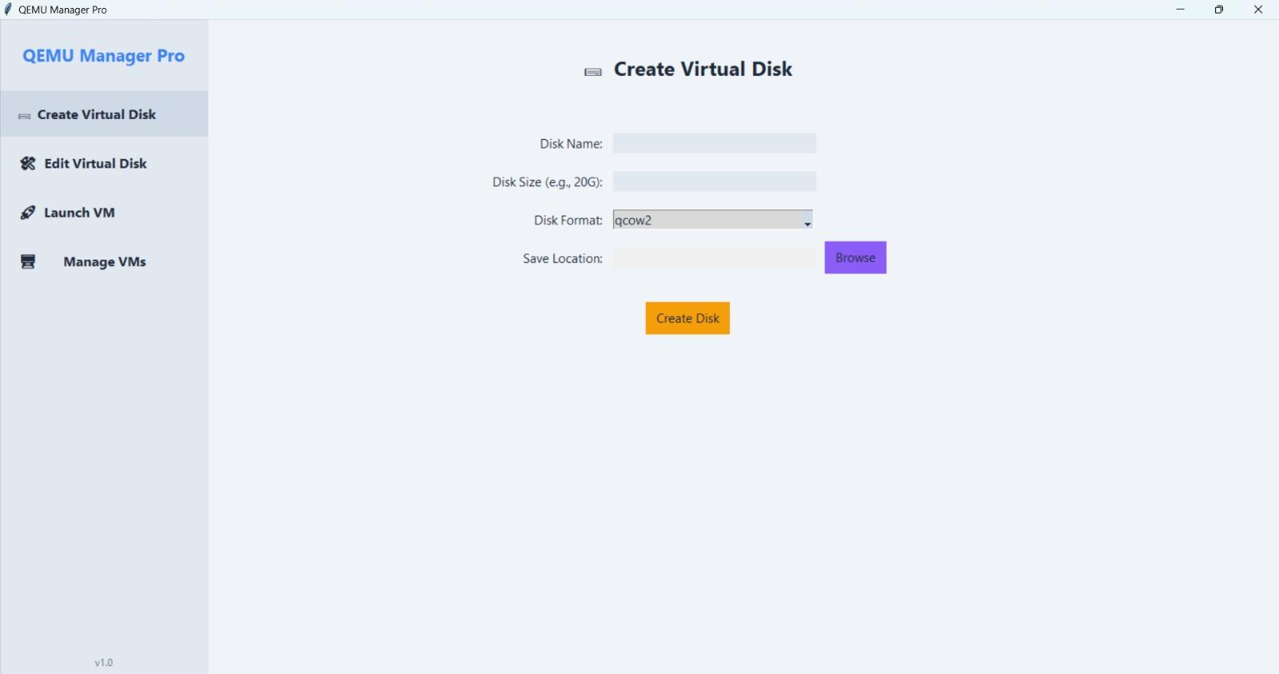

- Edit Disk Page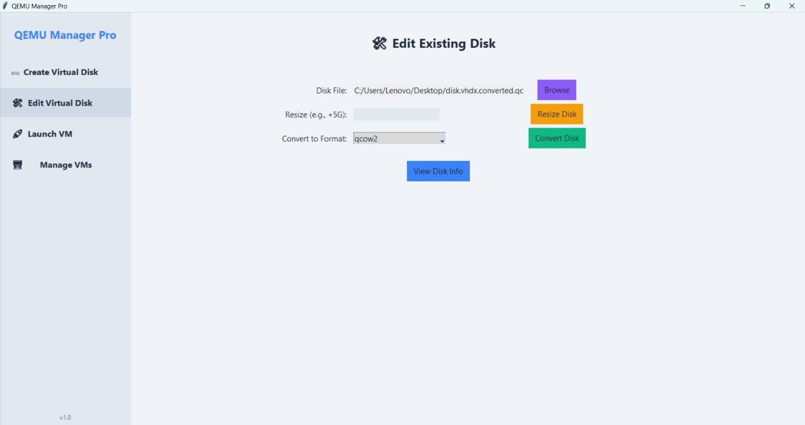

- Launch VM Page
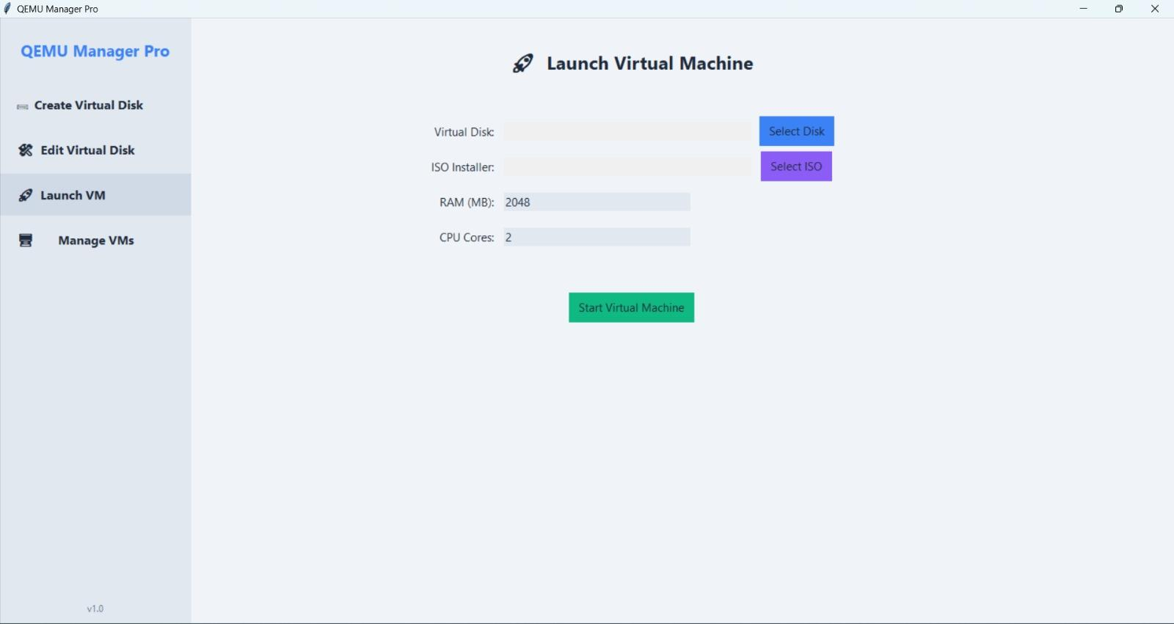

- Manage VMs Page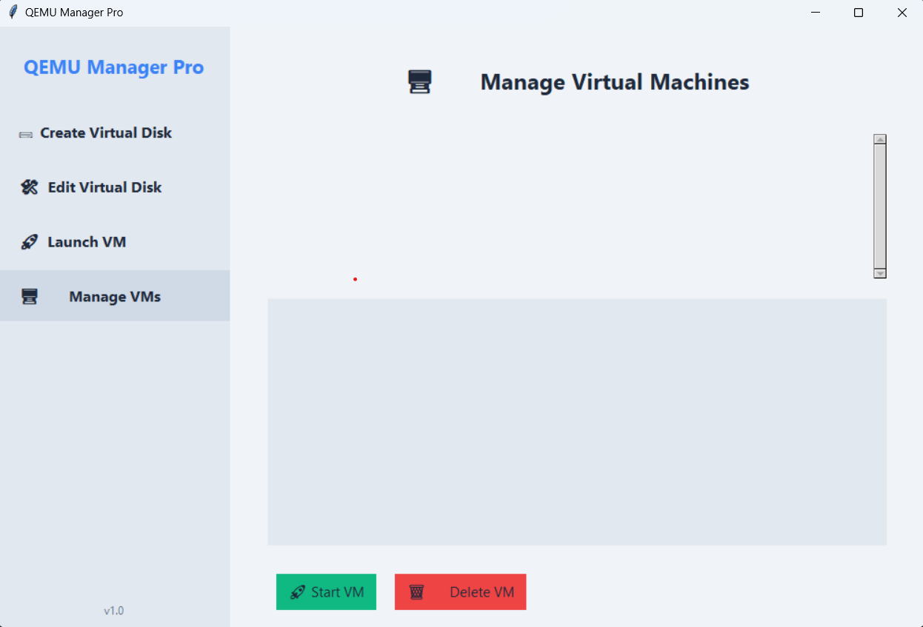
- Create Docker File Page
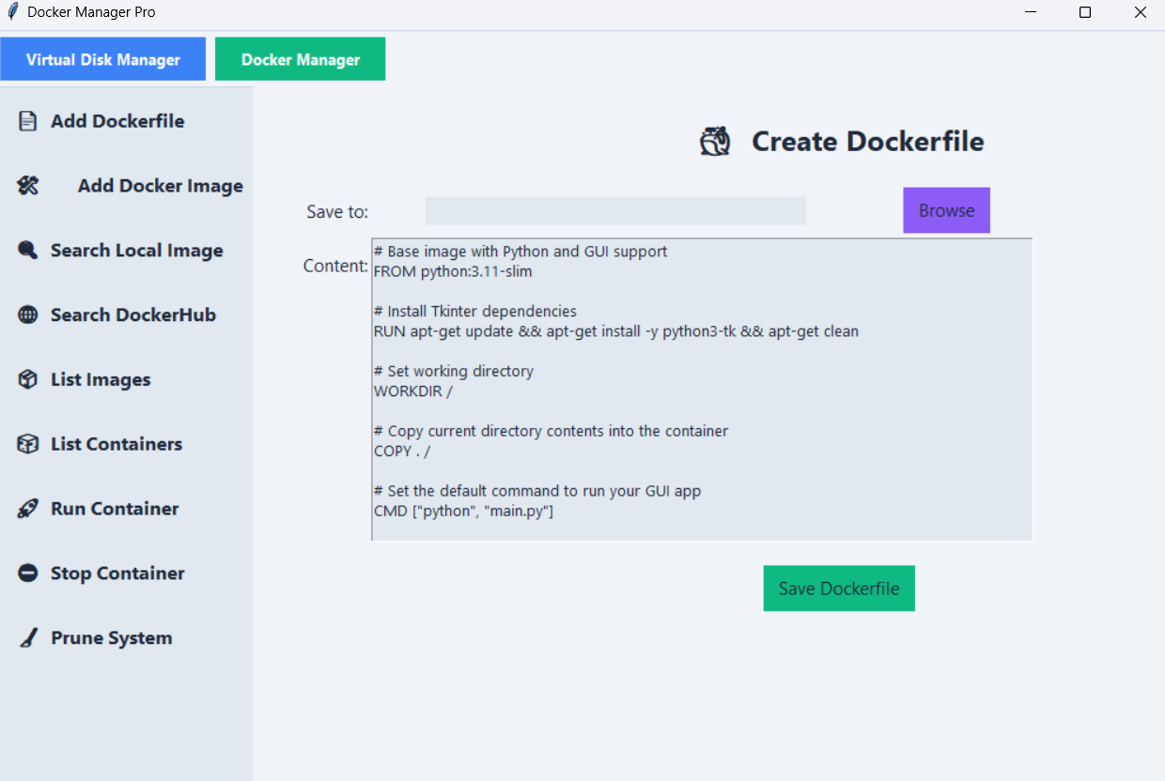

- Build Docker Image
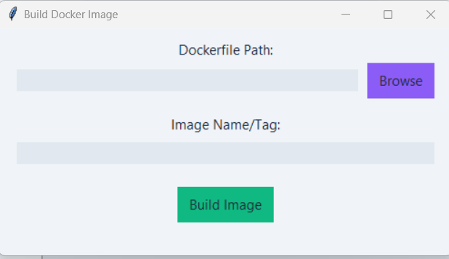

- List Docker Images
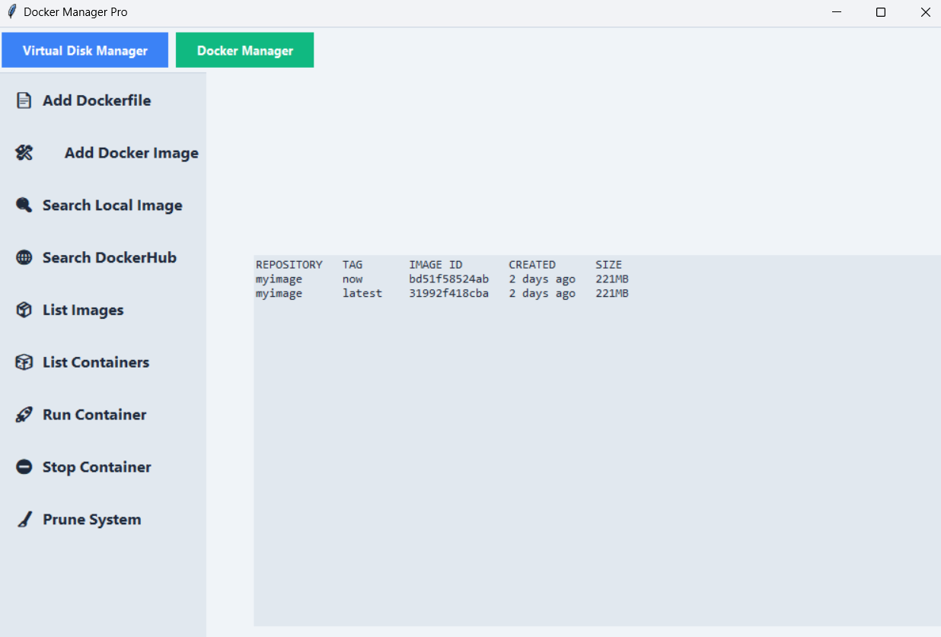
- List all the running containers
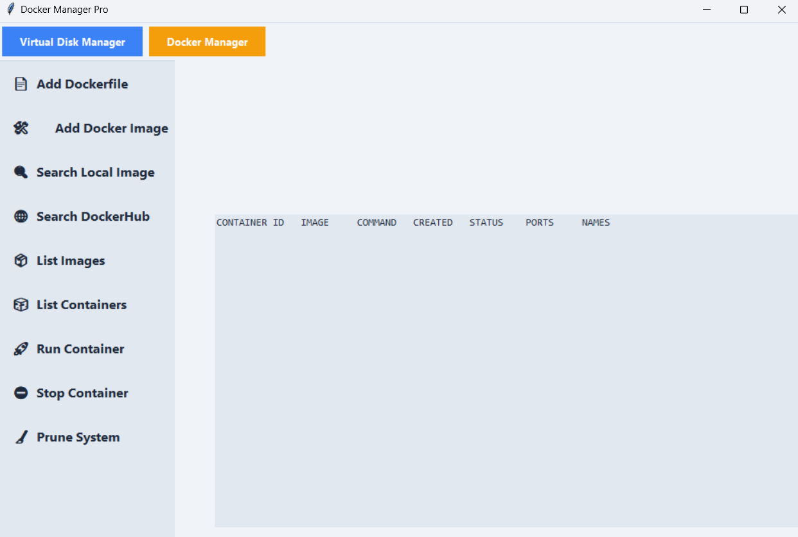

- Stop a Container
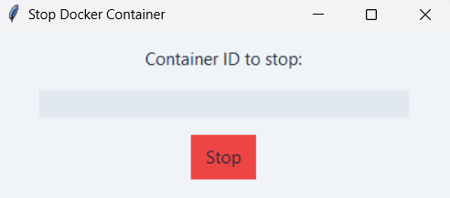

- Search Image
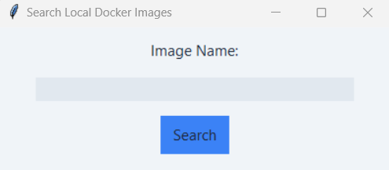

- Search for Image on Docker Hub
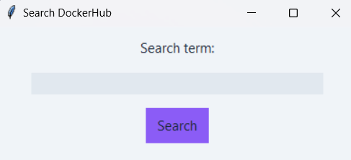

- Download/Pull Image

Docker Integration
- Utilizes subprocess.run() and subprocess.Popen() for all Docker commands
- Commands are constructed dynamically based on user input
- Errors and outputs are captured and shown via:
  - MessageBoxes (for simple messages)
  - Scrollable Text widgets (for logs)

QEMU Integration
- Disk Management Logic:
  - qemu-img is invoked via subprocess.run() for disk operations
  - Supports disk size validation and suffix checking (G, M, K)
  - Displays output or errors using messagebox
- VM Launching:
  - Uses subprocess.Popen() to non-blockingly start QEMU VMs
  - JSON config files are created in the projects directory
  - ISO and Disk are mounted with -cdrom and -hda respectively
  - Boot order set to CD-ROM (-boot d)

Multi-threading
- Long-running operations (Docker builds, QEMU VM launches) are run in background threads using threading.Thread to prevent GUI freezing

Error Handling
- Validates user input before executing commands
- Ensures required fields (image names, file paths, disk sizes) are not empty
- Checks if necessary components (Docker, QEMU) are installed
- Displays friendly error messages in case of:
  - Invalid Dockerfile or disk format syntax
  - Network issues during pull
  - Wrong container/image/VM names
  - Unsupported operations (e.g., resizing .vmdx disks)
- Input dialogs limit invalid formats

